**Tanzania Green Schools Program**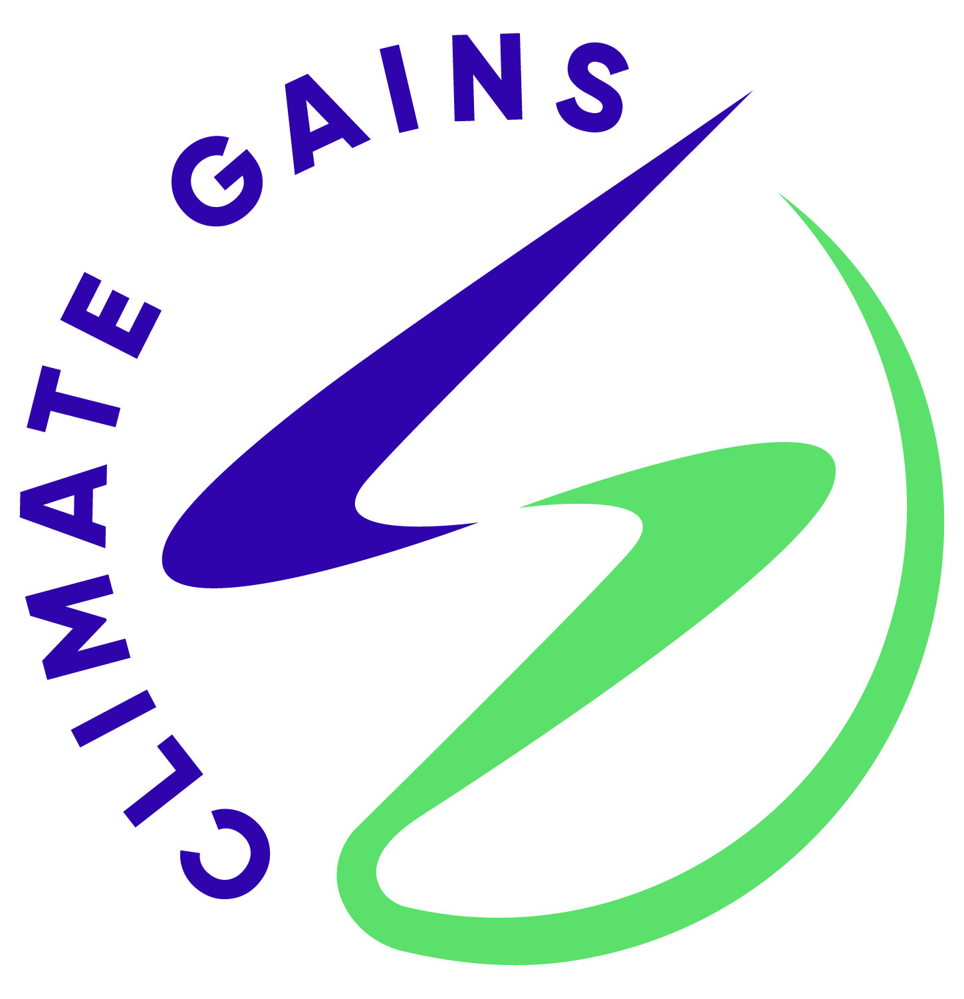

**Introduction**

Clean Cooking is the most common carbon project type across sub-saharan Africa, with many co-benefits and wide applicability. ClimateGains AG is a Swiss boutique Carbon Project developer, specialized in the development of Article 6 carbon projects for clean cooking in schools and other institutions.

Our program management is handled through our in-house developed ClimateGains app. It is based on a decentral process, where our local agents train and accredit construction companies across the country, who are then contracted to build and maintain the stoves upon requests from schools. The monitoring is based on video testimonials from the stove users that can be remotely verified. The carbon calculations are based on conservative national default values and student head count.

Our flagship program, the Ghana Green Schools Program is in the process of authorization under the Swiss bilateral carbon program and will start scale up later this year. However, we have initiated first operations in multiple other countries (Uganda, Kenya, DRC, Namibia and Tanzania), using the same approach and processes developed for Ghana.

Of those other countries, Tanzania is the most advanced. In particular, Tanzania has authorized the first Article 6 program on the 3rd of April, demonstrating their readiness (see <https://www.ncmc.sua.ac.tz/news/upenergy-achieves-historic-milestone>). We also completed a first pilot installation in Mlimwa C primary school partnering with Flawa Malle, a local youth climate activist and her NGO "Eco Pulse Network".

**Budget**

To develop a full fledged national program based on our experience in Ghana and the pilot study, we require the following steps over approximately one year:

- Full MADD Development (20'000 EUR)

- Stakeholder Consultations (50'000 EUR)

- Validation (30'000 EUR)

- Establishment of local management entity (20'000 EUR)

--------------

120'000 EUR

**Preliminary Numbers**

*NOTE: The precise numbers will be based on consultations with the Ministry of Education, Science and Technology as part of the full project development. What we present here is the result of a Google search on student numbers and the emission reduction numbers from Ghana.*

11.1 million students in primary schools, half of which have school feeding

2 million students in 5300 secondary schools, all of which provide schools feeding

- 100 kg CO2 per year per day students (most primary)

- 200 kg CO2 per year per boarding student (most secondary)

Potential: up to 1'500'000 tCO2 per year

Additional to the basic stove installation, the more comprehensive and complete approach to school cooking includes a solar water pre-heater and the establishment of a sustainable wood lot and local wood processing site, eliminating the use of non-renewable wood entirely. While the basic stoves can be constructed at scale immediately, this upgrade still requires some research and development work.

Potential: up to 3'000'000 tCO2 per year

**Cost estimate for the stove-only solution based on the pilot installation**

- Raw Cost: 4'000 EUR

- Students fed: 1700 day (primary school, day students)

-> 170 ITMOs / year

at 5 year crediting period:

5 EUR / ITMO

+ 25% overhead

**-> 7 EUR / tCO2**

Note that this number is highly preliminary and subject to change during the detailed MADD development & does not include any government fees or return for investors. See attached video for the report from the cook. More documentation from the pilot installation is available on request.

**Contact**

[www.climategains.org](http://www.climategains.org/)

[tim.reutemann@protonmail.com](mailto:tim.reutemann@protonmail.com)

Tel: 0041 76 519 4994

Whatsapp: +41 77 977 49 22